

Process Book

Visualising Migration to Australia: Insights and Implications

Tran Duc Anh Dang - 103955439

Luan Nguyen - 103812143

# Executive Summary

This report details the requirements, design, and validation of a comprehensive data visualisation project aimed at understanding migration patterns to Australia and their impacts on its demographic, economic, and social landscapes. The primary focus of the project was to create an interactive and user-friendly platform that allows a clear interpretation of complex data and fosters informed discussions.

Key features of the project include interactive visuals with zoom and filter functionalities, a clean and easy-to-read design, accurate data representation, and a geographical map highlighting immigration patterns. Optional enhancements included dynamic animations, an interactive legend, tooltip boxes for additional data, graph bordering axes, and temporal markers for added context.

The project was structured around five key questions related to migration patterns, demographic characteristics of migrants, and their impact on the Australian economy and workforce. The initial design phase utilized screenshots from existing data charts and preliminary sketches as a base. The final visualisation design incorporated a variety of visual tools such as heat maps, line charts, and bar charts, designed to provide a vivid and comprehensive depiction of the data.

Data validation ensured the use of reliable sources, the application of accurate data processing methods, and the correct representation of information in the visualisations. Established design principles and practices were followed, and interactive features were added for improved data exploration and understanding.

In conclusion, this project has been instrumental in understanding the complexities of migration to Australia and its multi-faceted implications. The interactive tools and visualisations designed in this project facilitate a clearer understanding of migration trends, providing valuable insights for a variety of stakeholders. The project underlines the importance of informed discussions and evidence-based decision-making in migration-related policies.

Link to our website:

<https://mercury.swin.edu.au/cos30045/s103995439/assignment2/source-countries/>

Table of Contents

Executive Summary 1

INTRODUCTION 3

1.1 BACKGROUND AND MOTIVATION 3

1.2 VISUALISATION PURPOSE 3

1.3 PROJECT SCHEDULE 4

DATA 5

2.1 DATA SOURCE 5

2.2 DATA PROCESSING 8

REQUIREMENTS 13

VISUALISATION DESIGN 14

4.1 Initial Visualisation Design 14

4.2 Final Visualisation Design 17

VALIDATION 22

CONCLUSION 23

REFERENCES 24

# INTRODUCTION

People around the world are attracted to Australia, by its economy, exceptional quality of life, and culturally diverse. Migration has recently been a hot subject among politicians, experts, and the general public. With the continuous discussion over migration policies and their impact on the country, there is a rising demand for comprehensive and accessible visualisations of migration data to better comprehend the trends and implications of migration in Australia.

## **1.1** **BACKGROUND AND MOTIVATION**

Migration, as a social phenomenon, is multidimensional and affects various facets of a nation. Its impacts are discernible in Australia's demographic composition, economic growth, cultural diversity, and even policy making processes. However, the process of understanding these impacts requires a large amount of data, which can be hard for many people to understand.

This is where our visualisation comes in. We designed this report for people to easily visualize, whether you are a policymaker, researcher, or student or even someone that is interested in the complexities of migration of Australia.

With a focus on clarity and comprehensibility, our visualisation presents migration data in a user-friendly format. It allows users to readily gain insights into the origins of migrants, their demographic characteristics, and how migration influences the Australian economy and society.

Beyond serving as an informative tool, our visualisation aims to stimulate informed discussions and support evidence based decision making. By highlighting the different aspects of migration, we aim to help people better understand this complex issue, fostering not just knowledge, but also empathy and a broader viewpoint.

## **1.2 VISUALISATION PURPOSE**

Australia is a well-known country with a long history of welcoming migrants from all over the world, so that migration is a hot and recent topic in Australia.

These visualisations below will help researchers, policymakers have various insights into how migrants contributed to the well-being of Australia. Furthermore, there would be some tools added that help users interact with the data to help it be more realistic. For instance, users can use visualized charts to identify the main source countries for migrants to Australia and track changes in the number of migrants over time. Line charts are useful for people to analyze the demographic characteristics of migrants, such as age, and gender. By understand these characteristics, policy makers and researchers are able to identify potential challenges and opportunities related to the integration of migrants into Australian society and the labor market.

Moreover, these visualisations will also provide various insights into how migration benefits the Australian economy, workforce, and population growth.

The impact on the economic and socialization could play an important role on migration as it is the important key for policy makers that responsible for making decisions about resource allocation, infrastructure planning as well as the aspects of economy policy.

Overall, a geographical map will be a valuable resource for anyone that is interested in understanding the complexities of migration of Australia and its impact on the country's society, economy, as well as cultural diversity. Therefore, Australia is ranked among the world’s best countries to be an immigrant.

## **1.3 PROJECT SCHEDULE**

* Week 2: Start working on the project. Summarize the project objectives and create a GitHub repository for group work.
* Week 3-4: Work on the project.
  + Prepare the appearance of the project process book.
  + Add some content with a focus on motivation and background (introduction).
  + Set up the website with some function or label, focusing on using HTML.
  + Plan the type of geometric that will be added to the project for data presentation.
* Week 5-7: Focus on data research and analysis.
  + Conduct research for needed data as discussed in Week 3.
  + Process data and convert it to charts using D3 for data presentation.
  + Provide details on data cleaning and acquisition for the workbook.
* Week 8: Finish working on the website.
  + Add suitable functions to present data properly.
  + Add some CSS effects to make the website look better.
  + Add JS for converting data using D3.
  + Check with the tutor.
* Week 9: Finalize the project process book.
  + Complete the content.
  + Add references.
  + Fix any grammar and spelling mistakes.
* Week 10-12: Finalize the project.
  + Receive feedback from the tutor to fix all issues.
  + Submit the final project.

# DATA

## **2.1 DATA SOURCE**

The project extensively utilised the Australian Bureau of Statistics (ABS) as a primary data source. Recognised as a dependable and comprehensive repository of statistical information, the ABS provided us with data that touched on various aspects of migration, including patterns, motives, opportunities, and survival needs. This wide-ranging dataset allowed us to create a well-rounded view of migration trends and impacts in Australia. It was our goal to contribute to a more sophisticated understanding of this multifaceted issue through a thorough data collection and analysis approach, which was pivotal in providing reliable insights and enabling informed conversations on the topic of migration in Australia.

This analysis involved several data files, each focusing on different aspects of migration:

* Source countries (source-countries.csv): This dataset comprises the following fields:

|  |  |
| --- | --- |
| **Field Name** | **Datatype** |
| Country of birth | Nominal |
| 2011 | Ratio |
| Percent (2011) | Ratio |
| 2021 | Ratio |
| Percent (2021) | Ratio |

Each record in this database is identified by 'Country of birth'. It presents two sets of data for each country, relating to the years 2011 and 2021. These data points represent the number and proportion of migrants from that country in the respective years.

* Net migration (net-migrant.csv): This dataset includes the following fields:

|  |  |
| --- | --- |
| **Field Name** | **Datatype** |
| Dat | Interval |
| NSW | Ratio |
| Vic | Ratio |
| Qld | Ratio |
| WA | Ratio |
| zeroline | Ratio |

The 'Date' field, at an interval level, represents time periods (quarters of the year). It does not have a true zero point but merely acts as a reference point. The fields 'NSW', 'Vic', 'Qld', 'WA', and 'Zeroline' indicate net migration figures for various regions, measured at a ratio scale. A value of zero in these fields would denote no migration in that period.

* Migration impact on workforce (workforce.csv): This dataset consists of the following fields:

|  |  |
| --- | --- |
| **Field Name** | **Datatype** |
| Residency Type | Nominal |
| Males(%) | Ratio |
| Females(%) | Ratio |
| Persons(%) | Ratio |

The "Residency Type" field is nominal, with categories that are exclusive and unranked. The fields "Males(%)", "Females(%)", and "Persons(%)" are ratio measurements, showing the percentage of each gender and total persons within each residency type.

* Migration's economic impact (economy.csv): This dataset comprises the following fields:

|  |  |
| --- | --- |
| **Field Name** | **Datatype** |
| Goods And Services | Nominal |
| Currency | Nominal |
| Migrant Households | Interval |
| Non Migrant Households | Interval |
| All Households | Interval |
| Arrived 2013 to 2016 | Interval |
| Arrived 2000 to 2012 | Interval |
| Arrived Prior to 200 | Intever |

The "Goods And Services" and "Currency" fields are nominal, with no specific order or numerical distance. The rest of the fields are interval measurements, signifying the average expenditure on each category by different household types.

* Demographic characteristics (demographics.csv): This dataset includes the following fields:

|  |  |
| --- | --- |
| **Field Name** | **Datatype** |
| Age | Ordinal |
| 2018-19 - Males ('000) | Interval |
| 2018-19 - Females ('000) | Interval |
| 2020-21 - Males ('000) | Interval |
| 2020-21 - Females ('000) | Interval |
| 2021-22 - Males ('000) | Interval |
| 2021-22 - Females ('000) | Interval |

The "Age" field is ordinal, as it follows a specific order. The remaining fields represent the population in thousands by age, gender, and year, and these are measured at an interval level.

## **2.2 DATA PROCESSING**

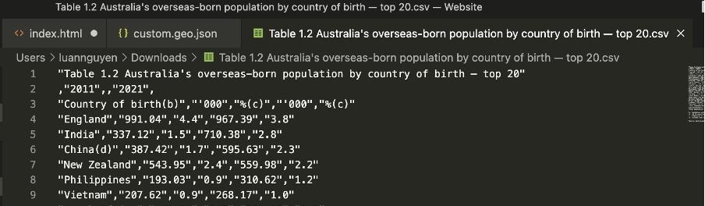

Figure 2.2.1: Source Countries

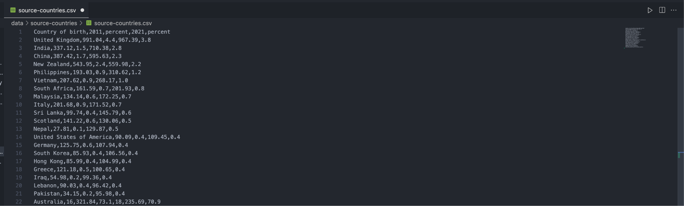

Figure 2.2.2: Cleaned Source Countries

In **Figure 2.2.1** and **Figure 2.2.2** present a detailed illustration of the data cleansing process, an essential stage in data preparation for analysis. This process is focused on the removal of extraneous elements such as table names, which often contribute to noise and detract from the primary value inherent in the dataset. By eliminating these irrelevant details, we enhance the integrity and usability of the data, facilitating more accurate and meaningful interpretations in the subsequent analysis.

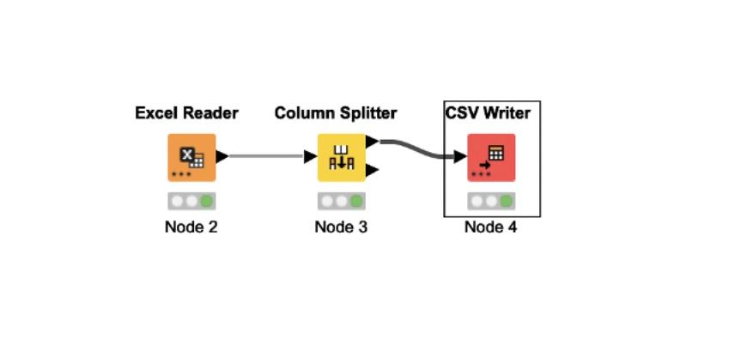

Figure 2.2.3 KNIME - Models

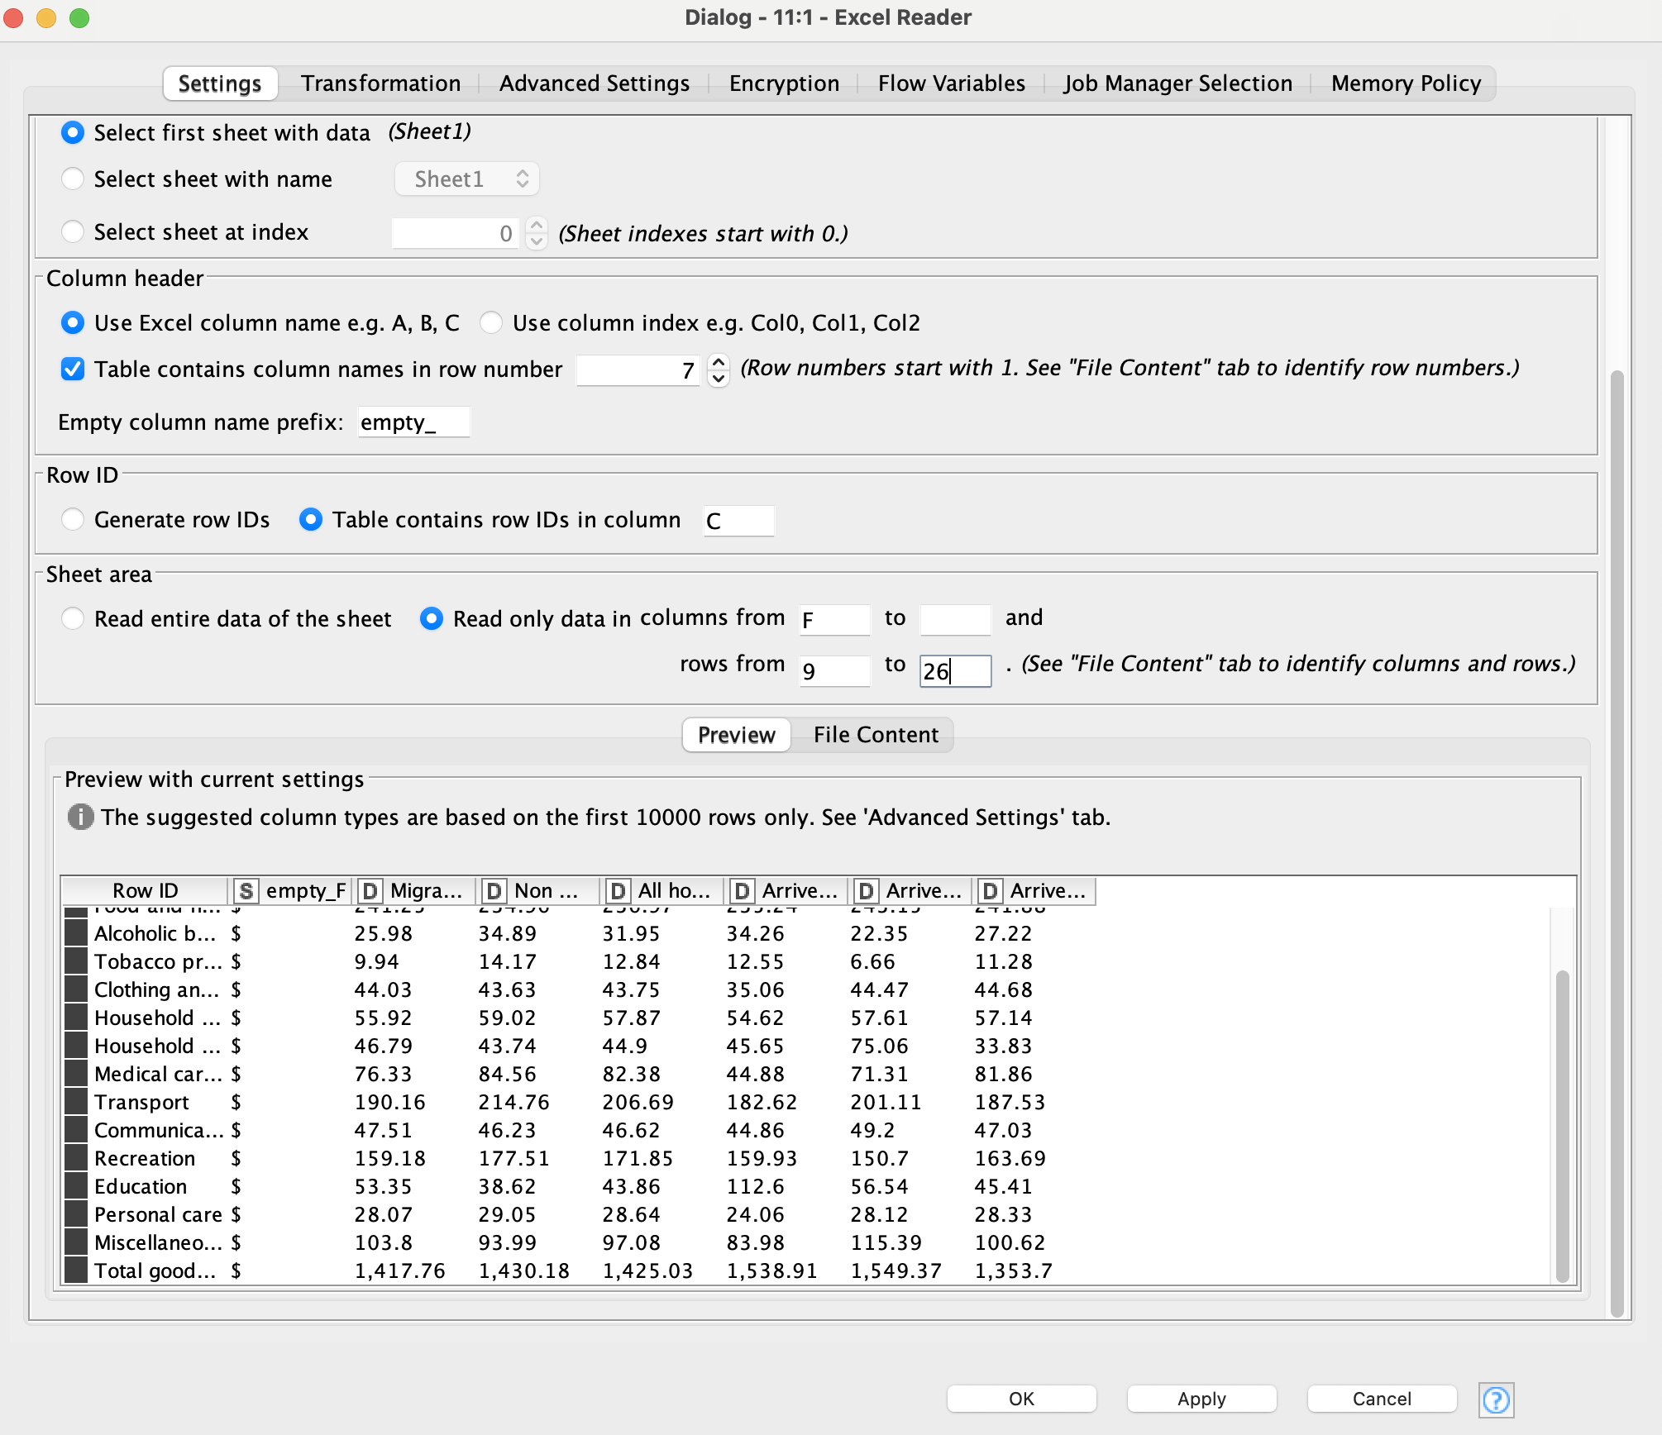

Figure 2.2.4 KNIME - Excel Reader

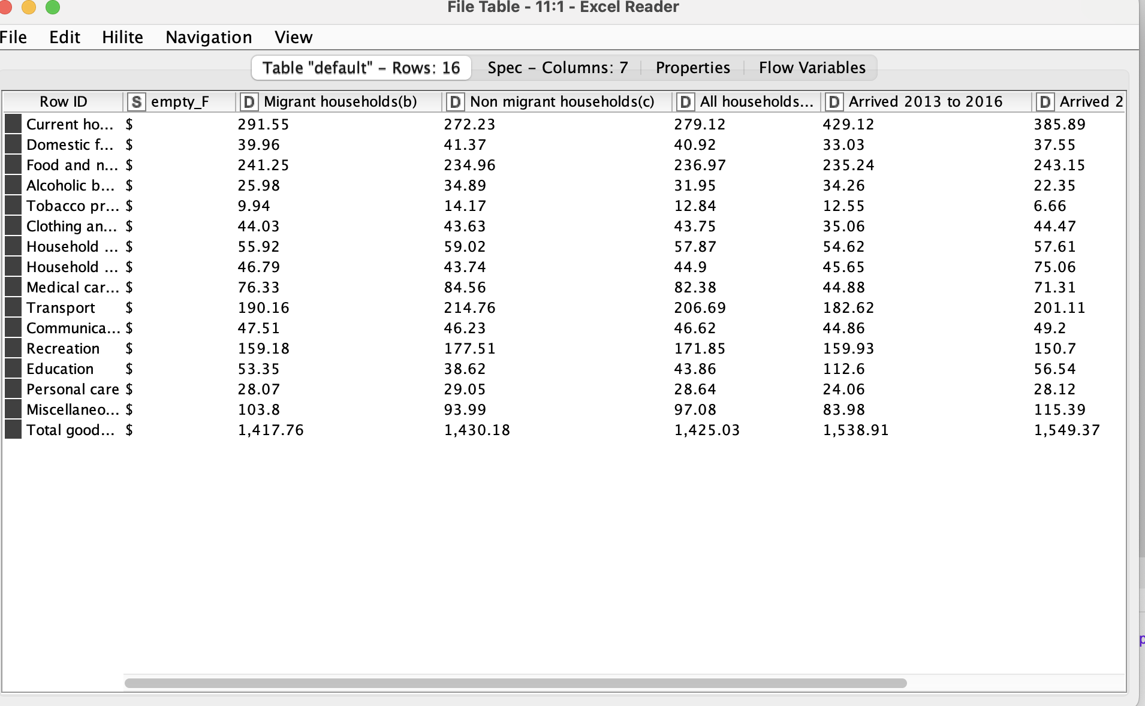

Figure 2.2.5 KNIME - Excel Reader

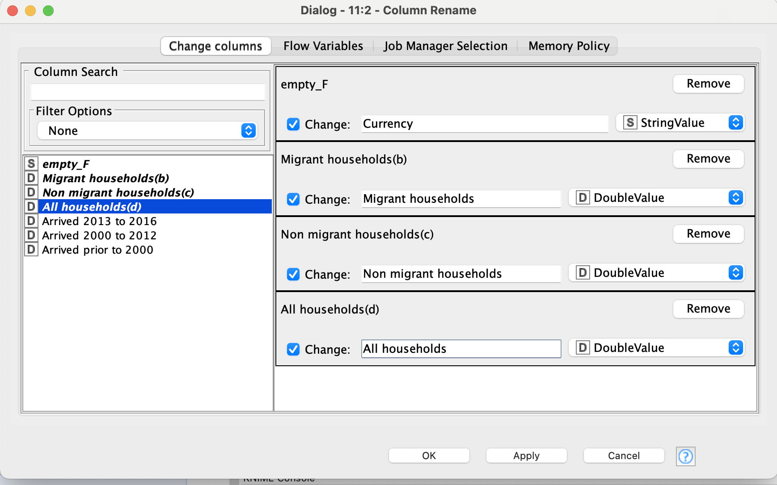

Figure 2.2.6 KNIME - Column Rename

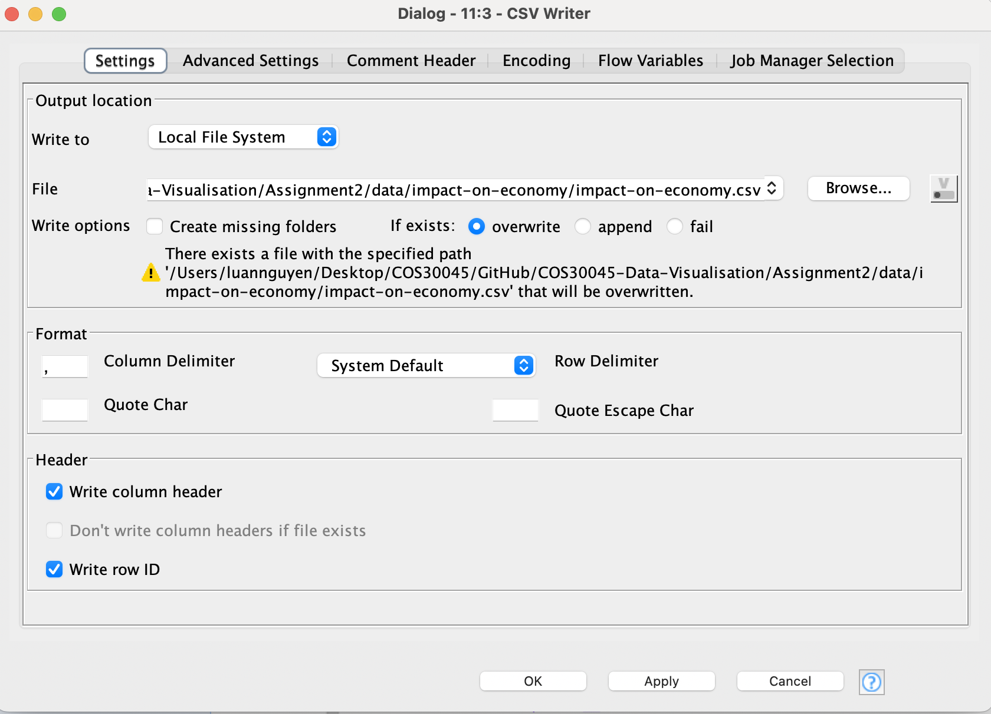

Figure 2.2.7 KNIME - CSV Write

In **Figure 2.2.3** is where the original data was found and from **Figure 2.2.3** to **Figure 2.2.7** is how we utilising the robust data analytics platform, KNIME, files are seamlessly loaded into the system via the Excel File Reader node. This specific tool permits the specification of required rows and columns from the data. Upon identification of relevant data, the Column Splitter node comes into play. Its function is crucial in separating necessary data from the extraneous, enhancing the concentration on pertinent information. The final stage of this data processing operation involves the CSV Writer node. This node ensures a streamlined transition of the sifted data into a CSV file, making it easily accessible and ready for any subsequent uses.

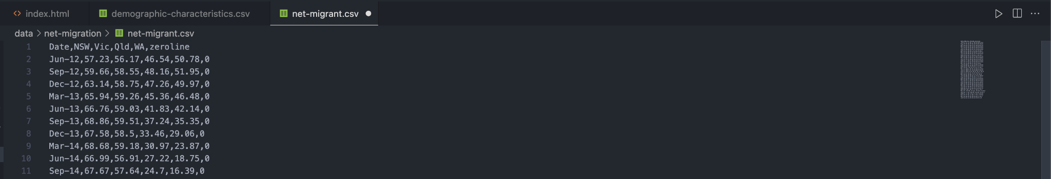

Figure 2.2.4: Cleaned Net Migrant

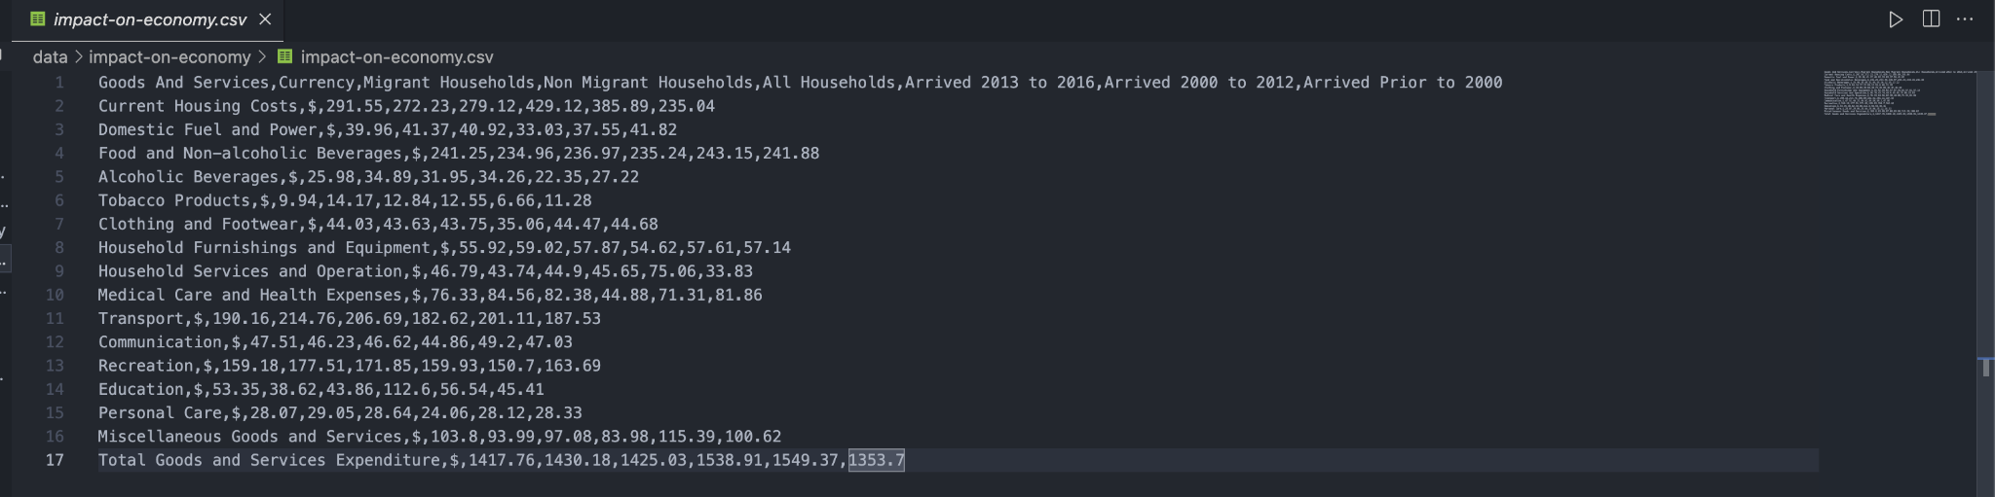

Figure: 2.2.5: Cleaned Impact On Economic

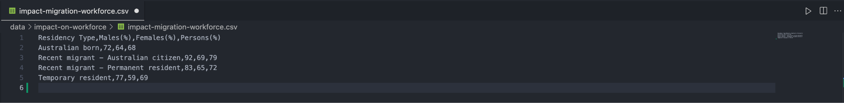

Figure 2.2.6: Cleaned Impact On Workforce

In **Figure 2.2.4** through **Figure 2.2.6** present the data that has been thoroughly cleaned and processed, showcasing key insights into the Net Migrant, Impact on Economy, and Impact On Workforce. Each figure represents a separate but interrelated facet of the data, thereby offering a comprehensive overview. These visualisations, free from noise and irrelevant information, help shed light on potential correlations and trends within these distinct areas. As such, they play an indispensable role in the ongoing analysis and interpretation of these three critical socioeconomic factors.

# REQUIREMENTS

In this section, it revolves around the critical features required for an impactful data visualisation project.

**Must-have Features:**

* Emphasizing user engagement, an interactive visualisation boasting zoom and filter functionalities is considered pivotal.
* To cater to varied inquiries, there are plans to design four distinct charts, each answering a specific question.
* Ensuring user-friendliness, the visualisation aims to adopt a clear and easy-to-read design.
* Guaranteeing the validity of insights, it is crucial to present an accurate and updated data representation.
* To enhance user interaction with the visualized data, interactive tools are envisioned as a significant part of the project.
* Highlighting immigration patterns, a geographical map indicating the source countries immigrating to Australia is deemed essential.

**Optional Features:**

* To create a more immersive experience, the incorporation of smooth and dynamic animations between visuals is proposed. This approach is believed to encourage users to explore and comprehend the data in a more intuitive manner.
* An interactive legend, toggling visualisation layers, is suggested to provide further clarity. Legends deliver vital information about colors and chart descriptions, thereby aiding user understanding.
* Tool tip boxes that display additional data upon cursor hovering could make the graph more informative and user-friendly.
* Axes for bordering are contemplated to enhance the visual clarity of the graph.
* Lastly, to add a temporal context to the data, lines indicating special events in recent years are considered. These markers could help users correlate significant occurrences with data trends.

# VISUALISATION DESIGN

## **4.1 Initial Visualisation Design**

Question 1: What are the main source countries for migrants to Australia?

There is no initial visualisation for this question

Question:2 How the number of migrants changed over time?

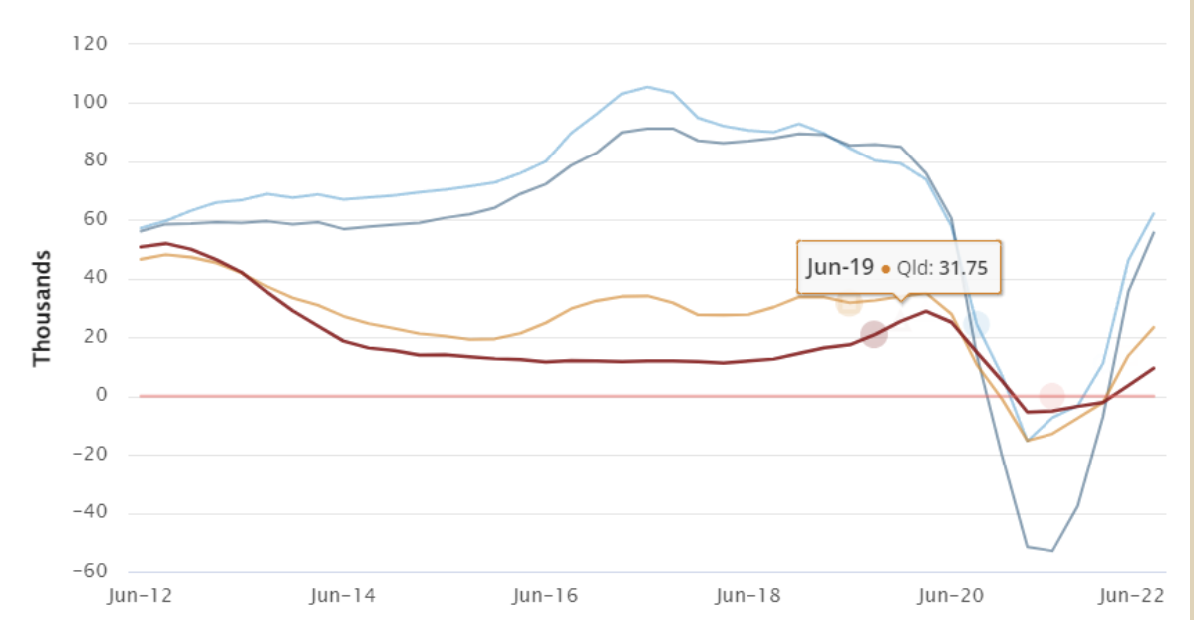

Figure 4.1.2 Initial Visualisation

In the early stages of Figure 4.1.2, a screenshot from a chart provided by the Australian Bureau of Statistics is taken. This preliminary chart outlines the fluctuations in migrant numbers over time. The dataset's design and chosen time frame offer a broad overview of the historical changes in Australia's migrant population.

Question 3: What are the key demographic characteristics of migrants (e.g., age, gender, education)?

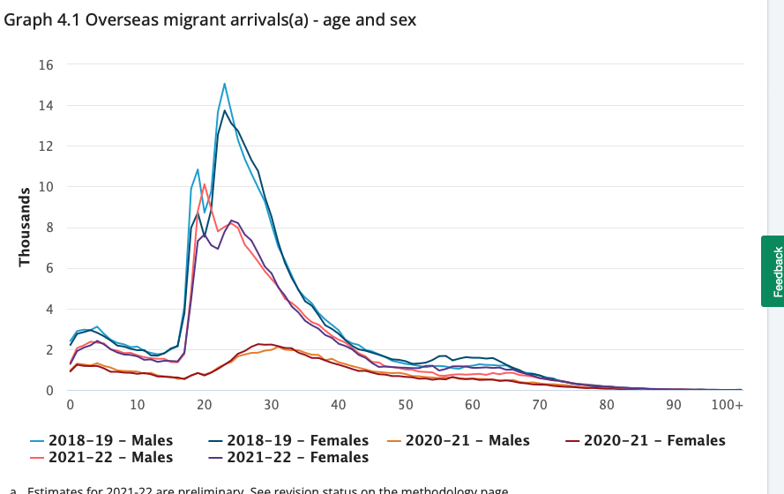

Figure 4.1.3 Initial Visualisation

The initial visualisation for Figure 4.1.3 uses a screenshot from a chart provided by the Australian Bureau of Statistics to display key demographic characteristics of migrants. This chart presents an initial understanding of the distribution of age, gender, and education among migrants to Australia.

Question 4: How does migration impact the Australian economy growth?

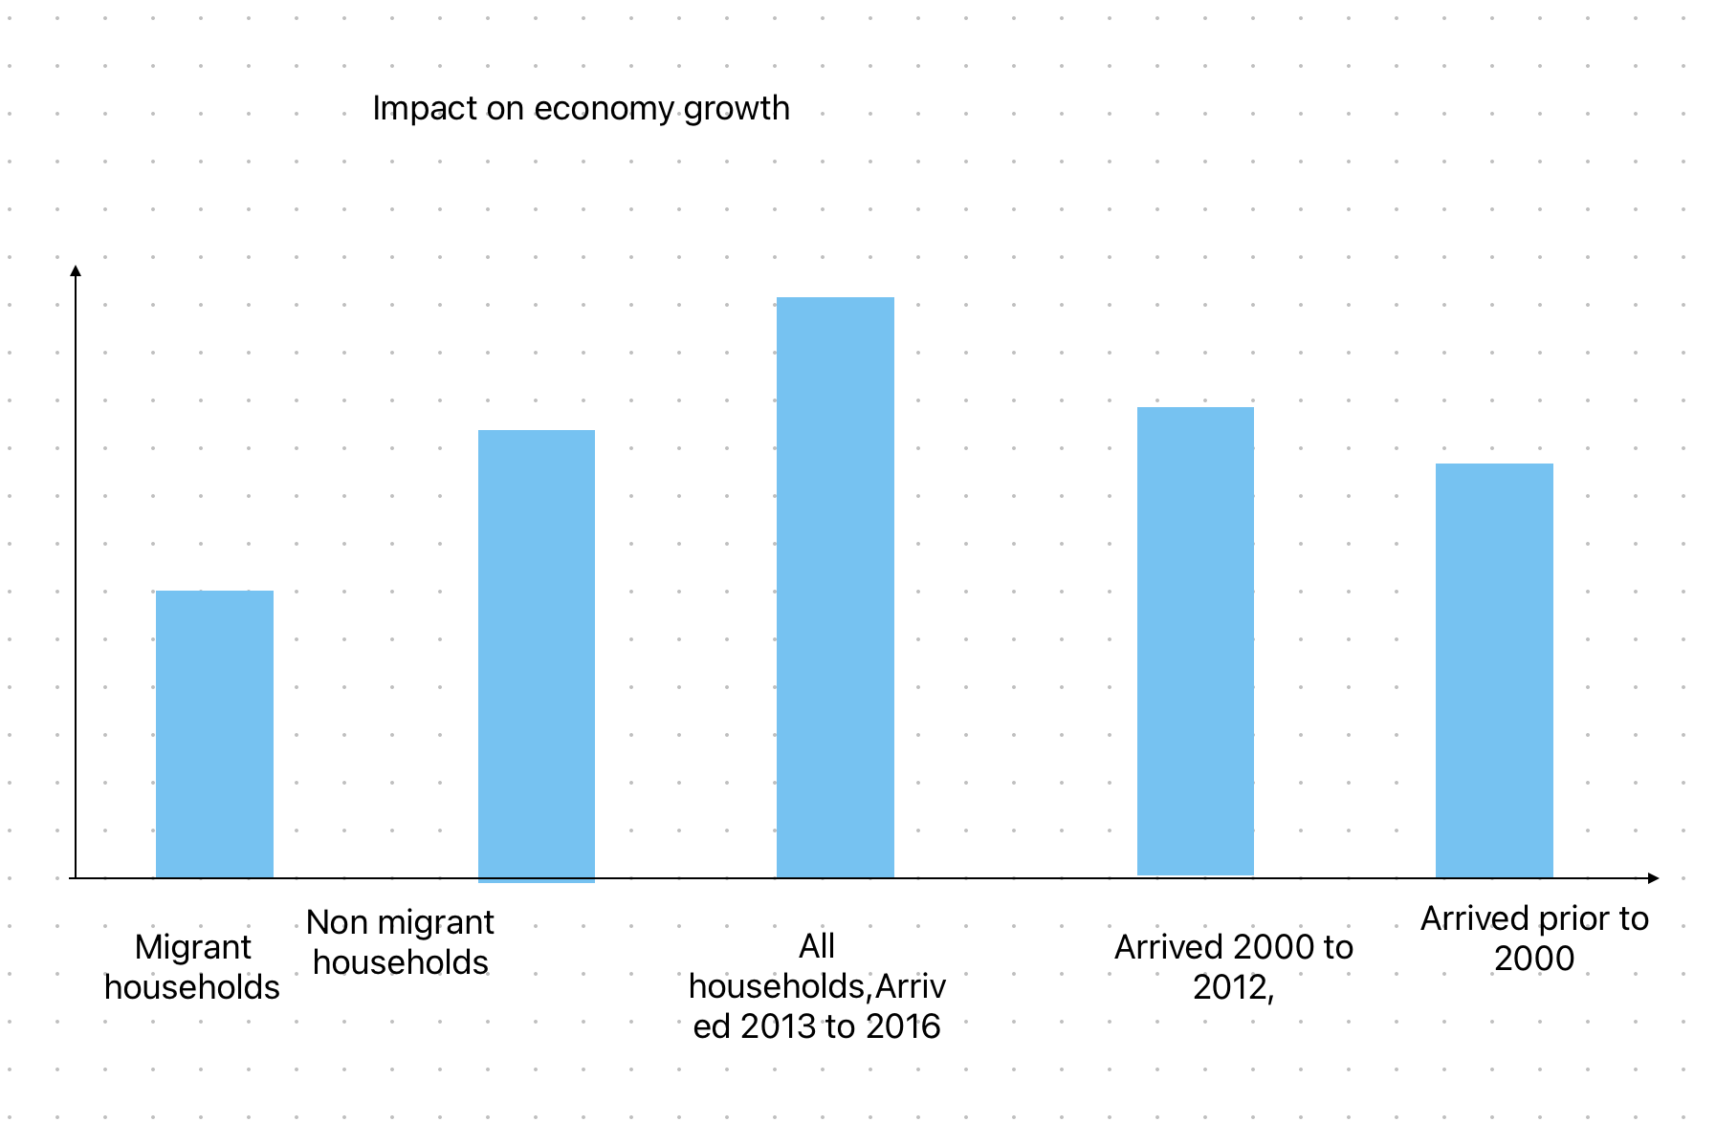

Figure 4.1.4 Initial Visualisation

For Figure 4.1.4, a draft is drawn using FreeForm to illustrate the potential impact of migration on Australian economic growth. This preliminary design serves as a conceptual sketch of how the final visualisation might look, showcasing how changes in migration numbers could potentially influence the country's economic performance.

Question 5: How does migration impact the Australian workforce growth?

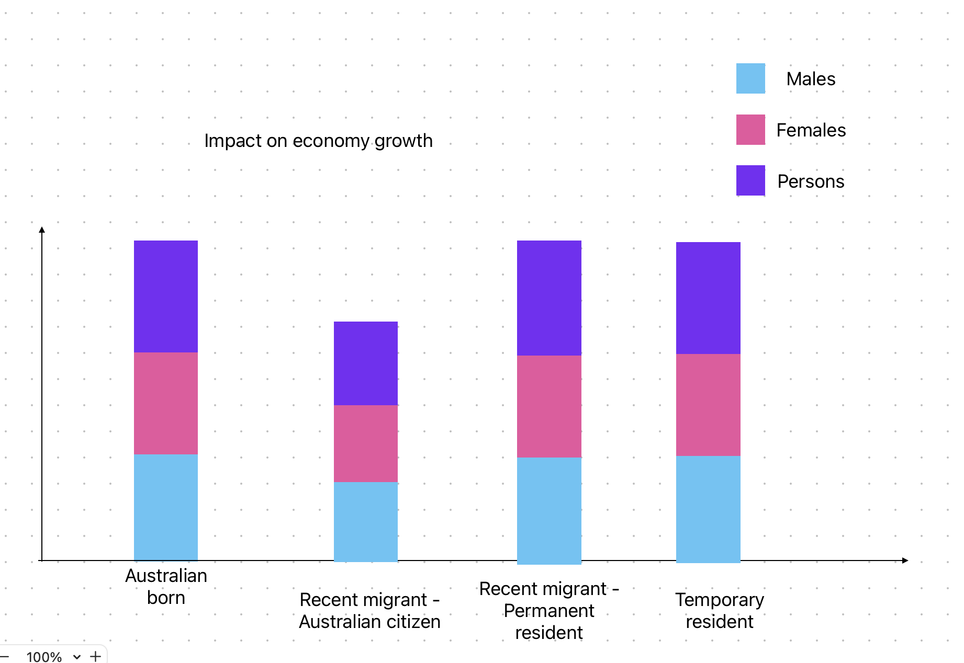

Figure 4.1.5 Initial Visualisation

In the initial visualisation for Figure 4.1.5, a draft is drawn using FreeForm to visualise how migration might influence Australian workforce growth. The sketch provides a rough blueprint of the final design, visualising the distribution of migrants across various work sectors and how their presence contributes to workforce expansion.

As per the information provided, the initial state is a combination of screenshots from existing data charts and conceptual sketches of the eventual design, serving as a stepping stone towards the final visualisations.

## **4.2 Final Visualisation Design**

Question 1: What are the main source countries for migrants to Australia?

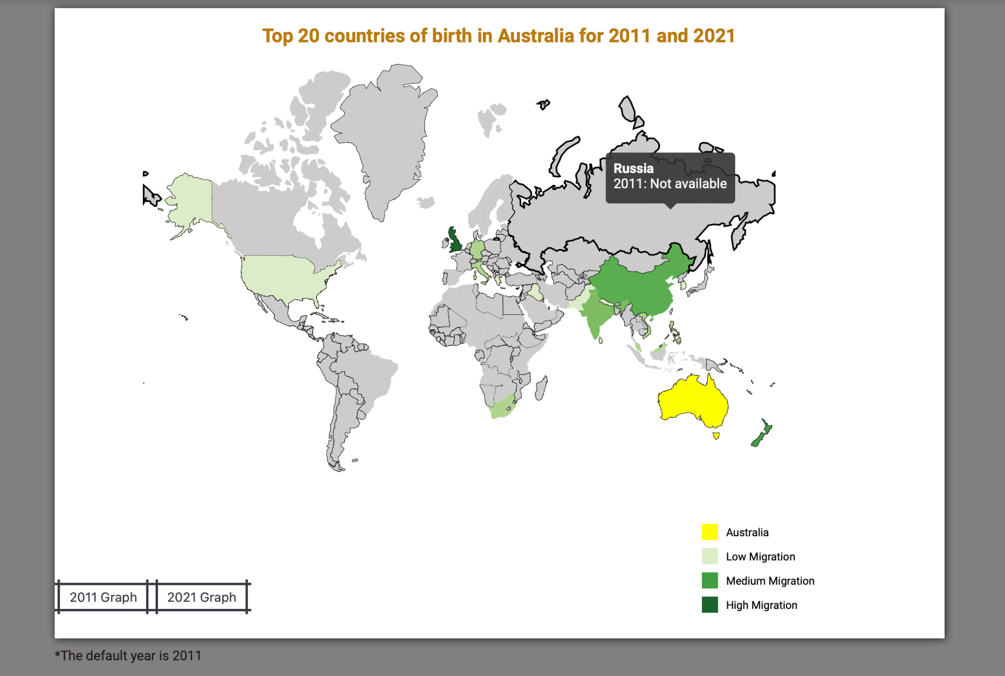

Figure 4.2.1 Final Visualisation

In Figure 4.2.1 utilizes a Heat Map to provide a vibrant and insightful visualisation of migration patterns to Australia in the years 2011 and 2021. By representing the source countries of migrants with varying degrees of color intensity, the map vividly illustrates the primary contributors to Australia's migrant population. The careful design and color-coding facilitate an instant grasp of the migration dynamics, significantly enhancing the understanding of how these patterns have changed over the decade. This innovative visual tool effectively answers the question about the main source countries contributing to Australia's migrant population.

Question:2 How the number of migrants changed over time?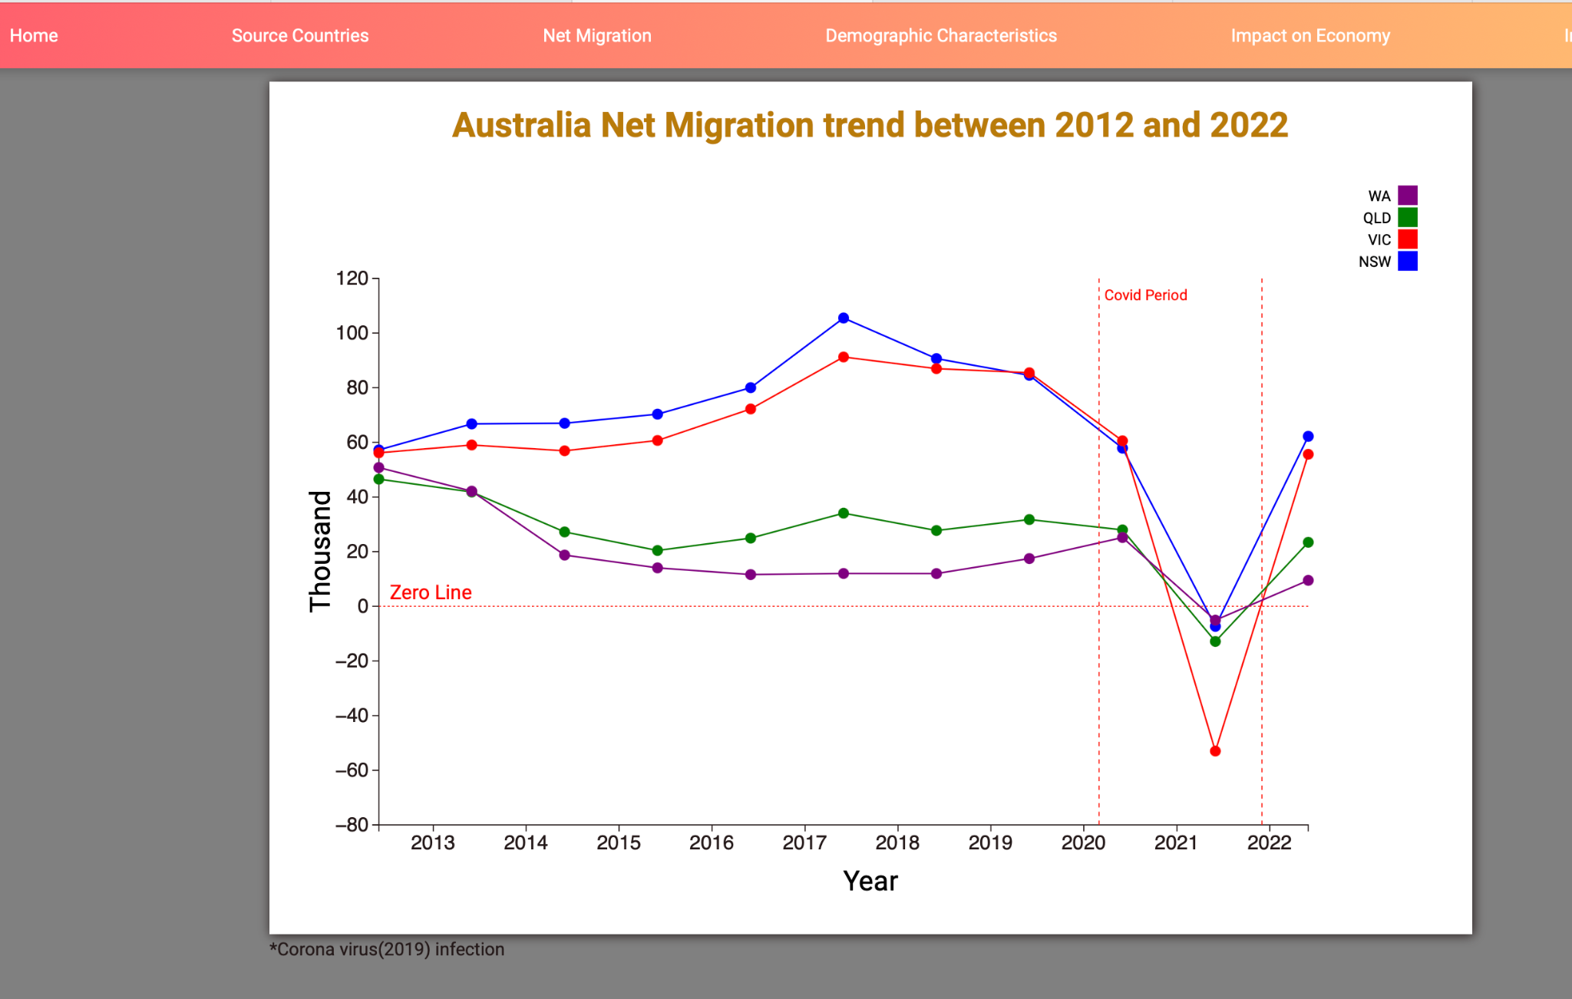

Figure 4.2.2 Final Visualisation

In Figure 4.2.2 employs a line chart to track the fluctuations in migrant numbers over time, showcasing annual data points. A striking observation from this graph is the pronounced dip in migration to Australia during the Covid 19 period. The chart distinctly presents New South Wales (NSW) and Victoria (VIC) as the two most preferred destinations for migrants. However, as the pandemic unfolded, VIC, being one of the strictest states in terms of lockdown measures, witnessed a substantial drop in migration. Despite this downturn, the graph also reflects VIC's remarkable recovery pace, quickly catching up with the migration rates of NSW. Thus, the line chart successfully elucidates the influence of global events like Covid 19 on migration trends over time.

Question 3: What are the key demographic characteristics of migrants (e.g., age, gender, education)?

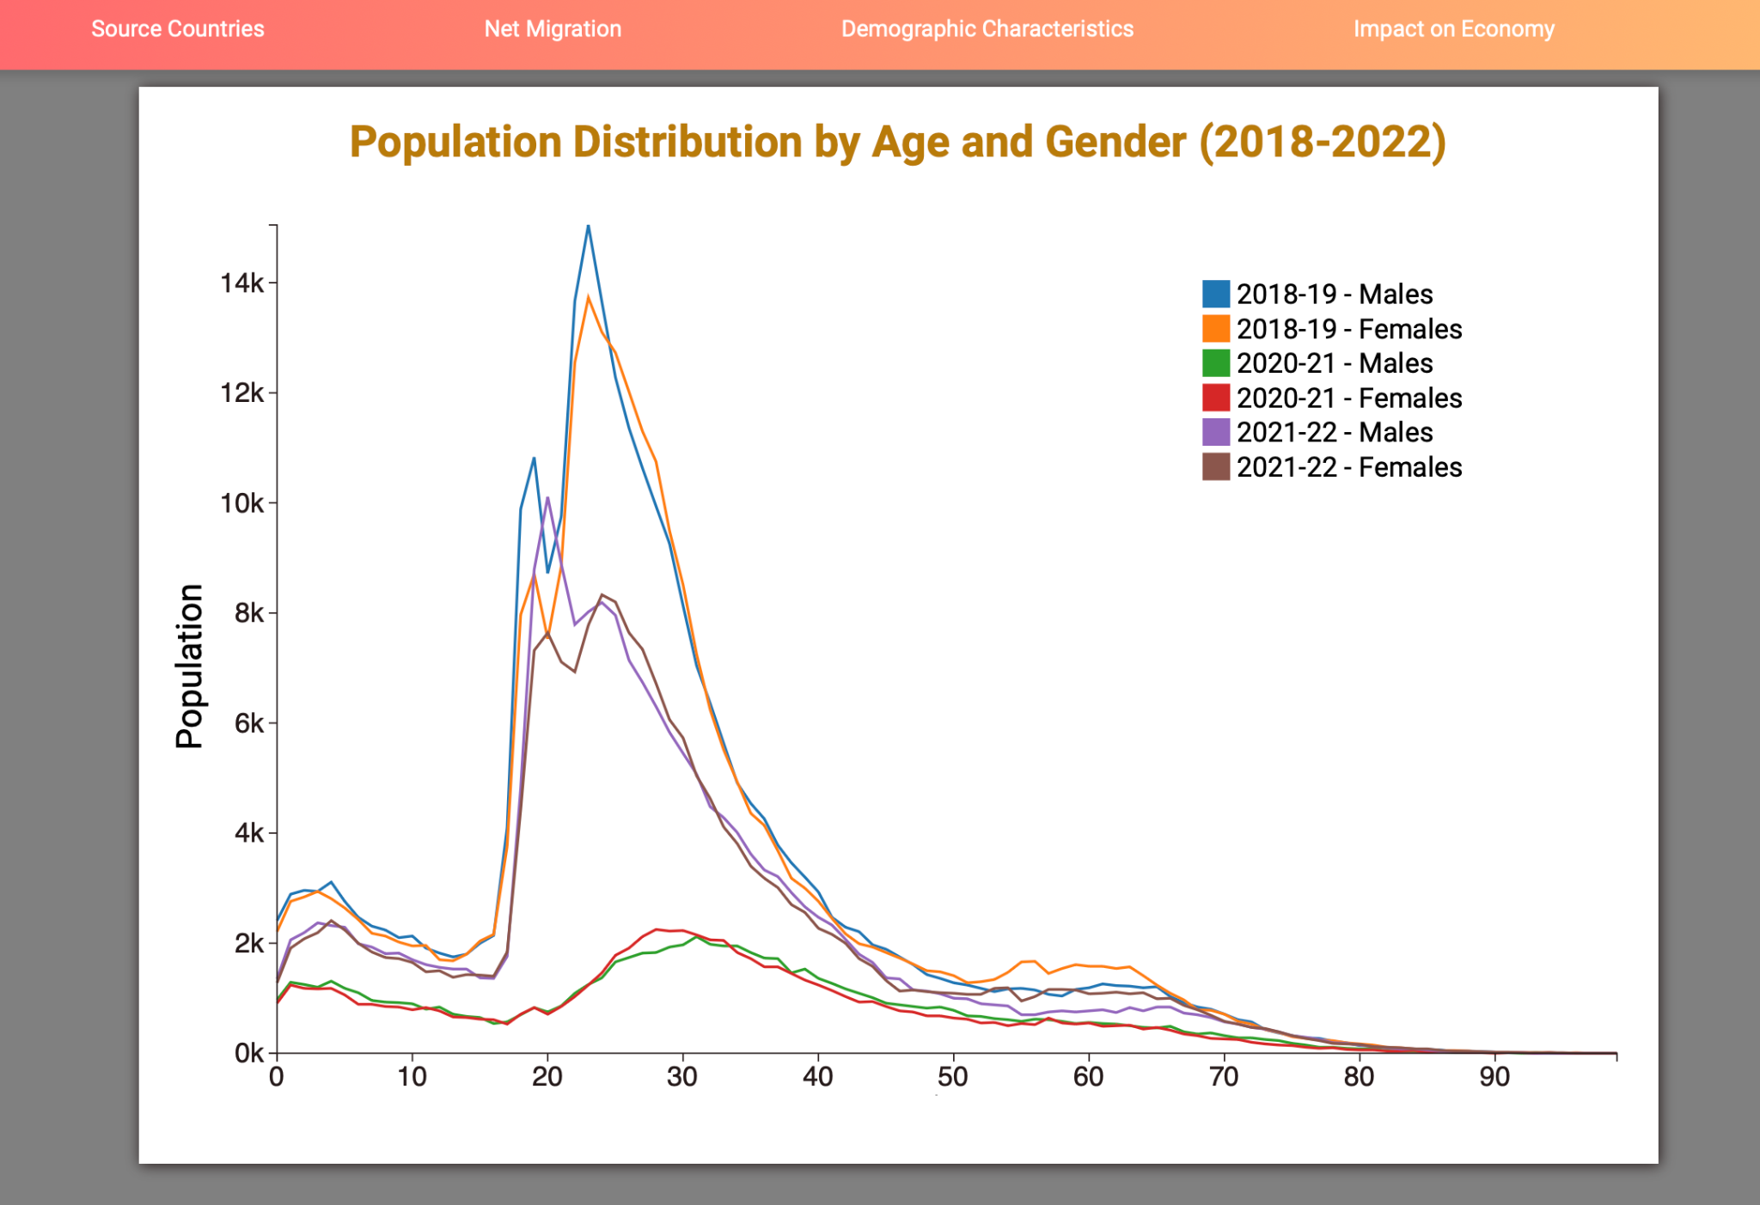

Figure 4.2.3 Final Visualisation

In Figure 4.2.3 integrates multiple line charts to exhibit key demographic characteristics of migrants, specifically gender and age distribution, from 2018 to 2022. By representing male and female migrants in separate lines, the chart effectively illustrates the gender dynamics of migration over time. Additionally, it incorporates a Population Distribution by Age chart, providing a more granular insight into the age brackets of the migrating population. The chart's design and time span enable a comprehensive understanding of the evolving demographic profile of migrants to Australia. Consequently, it offers valuable insights into age and gender trends among migrants, thus answering the question effectively.

Question 4: How does migration impact the Australian economy growth?

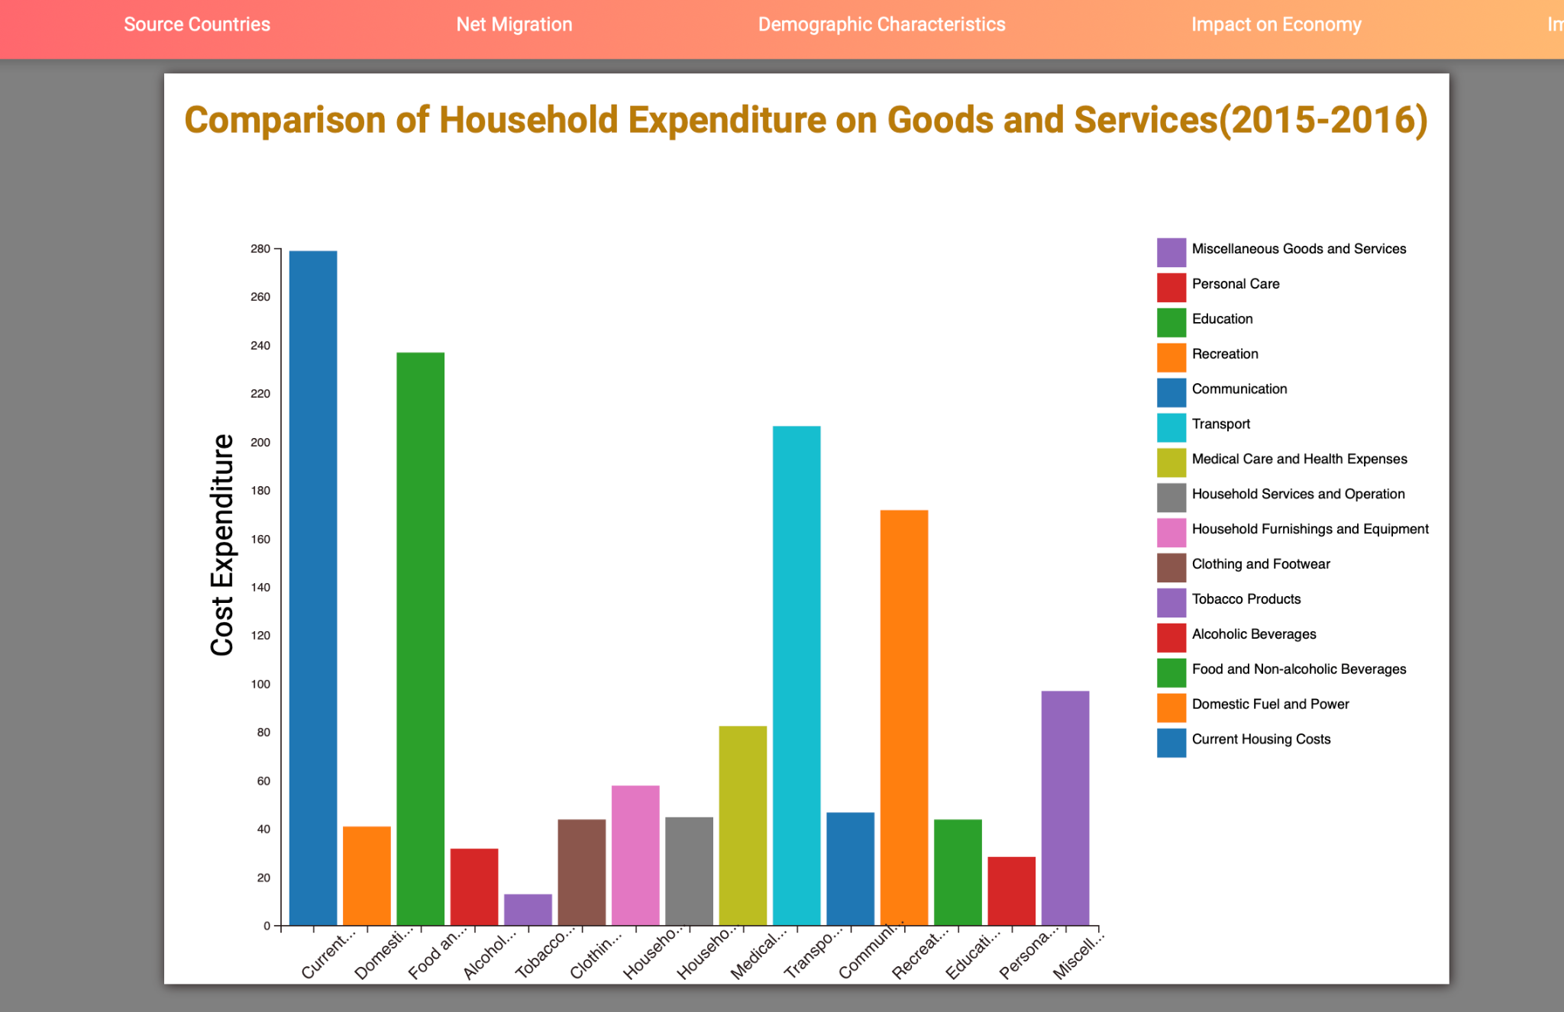

Figure 4.2.4 Final Visualisation

In Figure 4.2.4 employs a Bar Chart to elucidate the impact of migration on the growth of the Australian economy. This is accomplished by comparing household expenditure on goods and services. Each bar represents the correlation between the influx of migrants and subsequent shifts in expenditure patterns, effectively providing a snapshot of the economic implications of migration. This approach underscores the profound influence of migration on consumer demand, contributing significantly to economic growth. Therefore, Figure 4.4.4 offers a clear and intuitive response to the question concerning migration's role in propelling Australia's economic advancement.

Question 5: How does migration impact the Australian workforce growth?

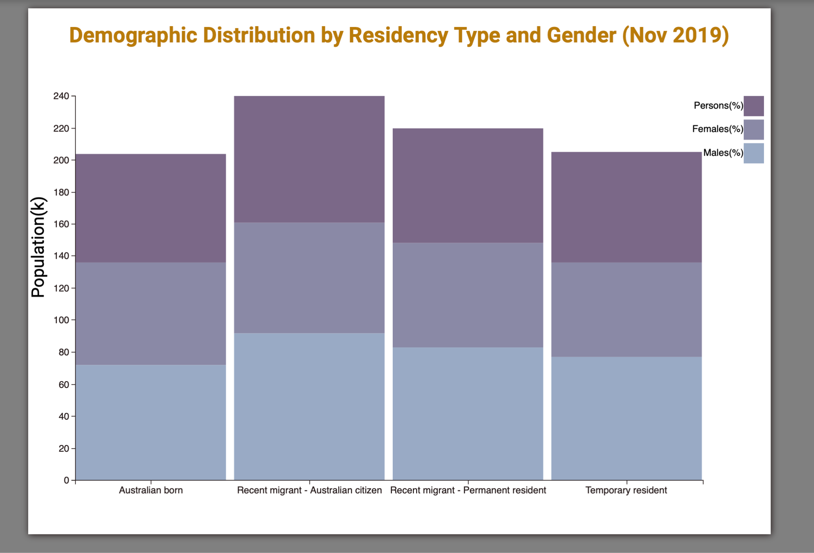

Figure 4.2.5 Final Visualisation

In Figure 4.2.5 employs a stacked bar chart to investigate the influence of migration on the growth of the Australian workforce. The chart showcases the distribution of migrants by gender, delineating between males, females, and others, and correlates this data with their residency type. This visual tool effectively paints a picture of how migration contributes to the diverse composition of Australia's workforce. By illustrating the gender distribution among migrants, the chart provides an understanding of the demographic changes brought about in the workforce through migration. Hence, Figure 4.4.5 effectively answers the question regarding the impact of migration on the expansion and diversity of Australia's workforce.

# VALIDATION

Validation in a data visualisation project primarily involves verifying that the data sources used are reliable, the data processing methods have been accurately applied, and the visualisations correctly represent the information conveyed by the data.

The data processing and cleaning steps were performed meticulously to ensure the data is accurate and suitable for analysis. The KNIME analytics platform was used to automate these processes, which reduces the risk of human error and helps maintain the integrity of the data. The cleaning process involved removing extraneous elements such as irrelevant columns and rows. Furthermore, data normalisation was applied where necessary to ensure consistent data formatting and comparability.

To ensure that our visualisations accurately represent the data, we followed established design principles and practices. These include appropriate choice of visualisation types (e.g., heat maps, line charts, bar charts) that match the nature of the data being represented, and proper labeling of axes, legends, and titles. Interactive features were also added to improve data exploration and understanding.

# CONCLUSION

Migration has a profound impact on Australia's demographic, economic, and social landscape. As detailed in the visualisation sections, migration has a significant role in shaping Australia's population structure, economic growth, workforce, and societal diversity. The questions posed and addressed in this project not only highlight the magnitude and complexities of migration to Australia but also offer insights into its multifaceted implications.

This report provides an interactive and comprehensive overview of migration patterns in Australia, aiming to simplify complex data for more accessible and informed discussions. It not only facilitates a clearer understanding of migration trends but also its impact on various aspects of Australia's landscape – from the economy and workforce to the demographic composition. The user-friendly, interactive tools used in this project enable users to gain insights into the origin countries of migrants, changes in migrant numbers over time, demographic characteristics of migrants, and the impacts of migration on the Australian economy and workforce.

In summary, the visualisations underline the significance of migration in Australia and contribute to a better understanding of this complex and multi-dimensional phenomenon. They underscore the importance of informed discussions and evidence-based decision-making in policies related to migration. Understanding the nuances of migration is vital for a range of stakeholders, including policymakers, researchers, students, and anyone interested in understanding the impacts of migration in Australia. The insights generated through these visualisations can play a pivotal role in shaping future migration policies and strategies.

# REFERENCES

1. Australian Bureau of Statistic (ABS). Characteristics of Recent Migrants, Australia. Availaible at: <https://www.abs.gov.au/statistics/people/people-and-communities/characteristics-recent-migrants/latest-release%20> (Accessed: 29 April 2023)
2. Australian Bureau of Statistic (ABS). Overseas Migration, Australia. Available at: <https://www.abs.gov.au/statistics/people/population/overseas-migration/latest-release#age-and-sex> (Accessed: 29 April 2023)